The SemiMaglev UrbanautTM – A New Total Monorail Concept
Einar Svensson, Pres. (Author) and John Svensson, VP and Technology Director (Co-Author)
January 25, 2005
The Urbanaut® Company, Inc.
P.O. Box 1408, North Bend, WA, 98045, USA
(425) 434-6570 / Fax (425) 434-6566, svensson@empnet.com
Keywords: Bogies, LIM, Monorail, SemiMaglev, Urbanaut.
Abstract
The SemiMaglev Urbanaut™ technology represents a new innovative, unique, energy-efficient, considerable less costly, high-capacity total monorail passenger transportation and light freight concept. It incorporates all aspects of monorail technology, including vehicles, guideways at surface and elevated stations, with 3 options of simple inexpensive switching. The technology applies vertical magnetic levitation forces that vary from 0 – 100% depending on economics and application. Load wheels are partially applied to conserve energy and for flexibility when the vehicle is stationary as is in a station, in the maintenance area, etc. The aerodynamic shaped vehicles have the option of 3 propulsion systems, on board vehicle, or in the guideway, depending on speed .Vehicles ride on top of a narrow runway at surface, in tunnels, on bridge decks, or on prefabricated elevated guideways. The Urbanaut® technology does not envelope a massive beam way like most other monorails in operation today, it is smaller, lighter, consume much less energy, and has unlimited flexibility. A uniquely shaped central rail, ideal for maglev in the center of the runway physically guides and stabilizes the vehicle. Permanent magnets attached to vehicle bogies interact with embedded material in the guideway to provide propulsion, lift and guidance.

1 Introduction
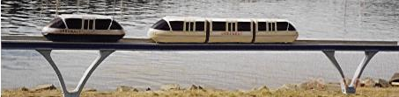
Figure 1
The Urbanaut® is a light weight, independent, innovative medium-to-high speed Semi or Full maglev transportation system applicable in medians of highways and in densely populated areas, communities and recreation areas where space, pollution and other environmental restrictions do not permit conventional wide-guideway transportation systems. It is adaptable to high, medium and low speed depending on a project’s route planning, capacity and economics. The Urbanaut® system has boundless flexibility in planning and application in transportation technology [16].
The SemiMaglev Urbanaut™ Monorail is a trade name of The Urbanaut® Company, Inc. There are numerous issued patents and patents pending worldwide on all aspects of the technology, including two issued in China. The concept is unique in several respects and is the only monorail in which a smaller vehicle operating on a smaller guideway can be seamlessly integrated with and switched onto a larger higher capacity system [3][18][19].
By applying the simpler new SemiMaglev Urbanaut™ total monorail technology, with its small vehicle and guideway, the high cost of conventional construction of massive maglev guideways [2][4][9] and vehicles can be reduced considerably. The safety and stability of the Urbanaut® system has been determined by extensive engineering studies and large scale model testing of vehicles and guideways.

2 New Technology

2.1 Basic Principle of the SemiMaglev Urbanaut™
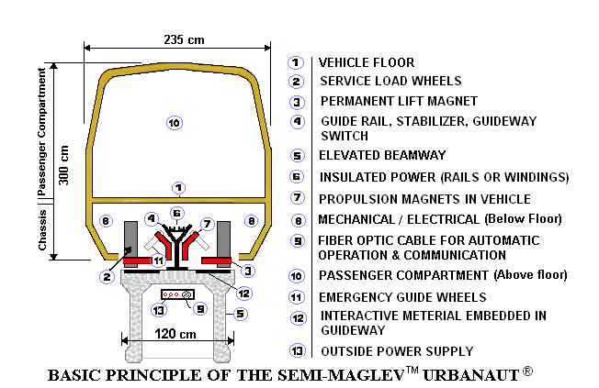
Figure 2
The SemiMaglev Urbanaut™ system is not dependent on a massive enveloping beam way as other monorails, but utilizes a narrow runway which can be on an elevated beamway, a slab at surface or subsurface. No parts of the vehicle will extend below the top surface. Electric automatic light weight maglev vehicles that ride on top of the runway are guided and held in place by a single center rail, which also serves as a simple switch for guiding vehicles from one guideway to another. The magnetic contacts along the guide rail make the system ideal for maglev at low, medium and high speed applications. The technology is adaptable to semi-maglev or full maglev concepts, depending on application and economics [18].
2.2 Dynamic Stability of the Vehicle  Ideal for maglev, a center rail with a uniquely shaped head (Fig. 3) dynamically guides and stabilizes the vehicle against excessive wind (WB) and centrifugal lateral forces (ZB).  The guide rail head configuration locks the vehicle to the guideway and derailment is virtually impossible. (Patents issued allow for different shapes of the head for emergency guide wheels). [18] Permanent magnets interact with embedded material in the guideway to provide levitation and guidance. The vehicle has a low center of gravity, and exceptionally low aerodynamic and magnetic drag resistances [23][24].  Figure 3 |  | 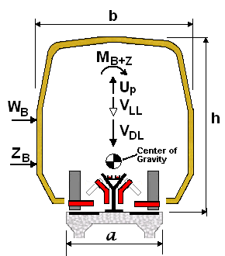
Guideway is approximate half the width of the vehicle  Forces on the vehicle are transferred through a bogie  to the guideway  a= Width of guideway  b = Width of vehicle  h = Height of vehicle | VDL = Weight of vehicle (dead load)  VLL = Passenger loading (live load)  Up =Uplift of vehicle  MB+z =Lateral moment on vehicle

3 SemiMaglev Urbanaut™ Vehicle Bogies
3.1 Comparison of Conventional Rubber Tire and SemiMaglev Urbanaut™ Vehicles

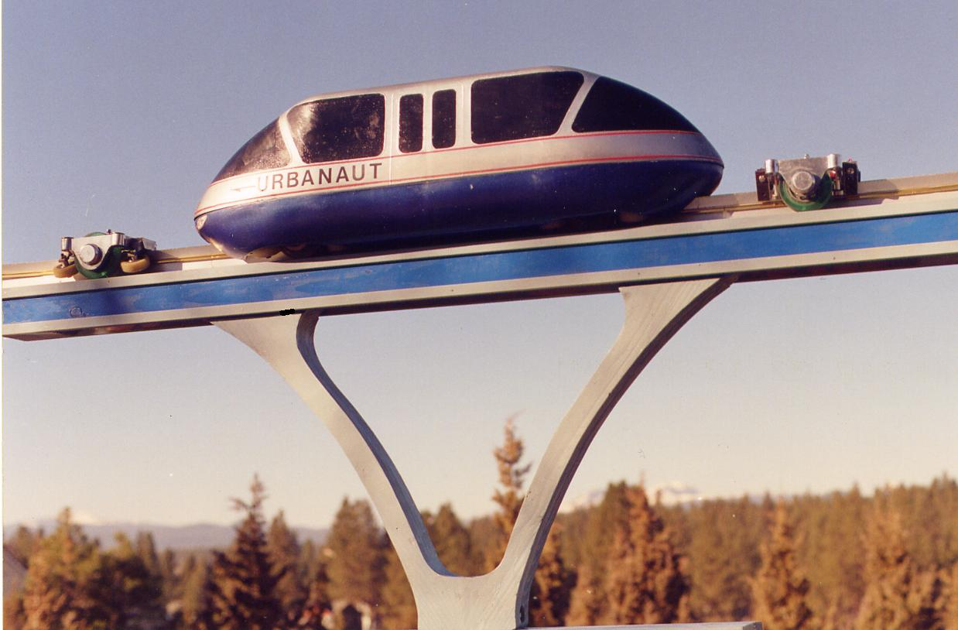 Figure 4

Figure 4 is a photo of a typical Single Urbanaut® vehicle on an elevated guideway illustrating size and shape of 2 types of compact bogies:

1) A rubber tire wheel bogie in front with larger wheels (at left)

2) A SemiMaglev Urbanaut™ bogie, with smaller wheels, in the rear (at right), on an elevated guideway.

The basic difference between the 2 bogies is that the SemiMaglev concept permanent magnets are mounted inside the bogie to provide an air gap between the wheels and the guideway.
3.2 SemiMaglev Urbanaut™ Bogie Components (See Figure 5)
A SemiMaglev Urbanaut™ vehicle has 2 maglev bogies, located in the front and rear ends of the vehicle. The 2 bogies are the most important components (the “brains”) of the vehicle. Since all the vehicle components for supporting, guidance, suspension, propulsion and levitation are built into the bogie, special pockets in the chassis have been designed and engineered for easy installation, service, and removal of the bogies. The bogies are the link between the concrete runway and vehicle body above
3.2.1 Service Load Wheels to Preserve Energy – SemiMaglev Technology. The 2 smaller load wheels can be partially loaded, for safety, to save energy and to simplify operation. While the vehicle is at stations, in service, during switching, etc., there is no vertical levitation energy used. Weight from the load wheels is transferred from the vehicle bogie frame to the concrete runway below.
3.2.2 Combined Propulsion, Guidance and Lift by Permanent Magnets. All lateral forces such as centrifugal forces and wind acting on the vehicle are transferred to the center guide rail, which is anchored to the structural guideway below. Air cushioned permanent magnets in the vehicle interact with the magnetic elements in the guide rail and runway to create combined propulsion, guidance and lift of the vehicle.
3.2.3 Primary and Secondary Suspension. Primary suspension between the vehicle body and the bogie is provided by air-bags confined within the 4 corners of the bogie. Secondary suspension and damping are by magnets in the bogie, interacting with elements in the guideway.
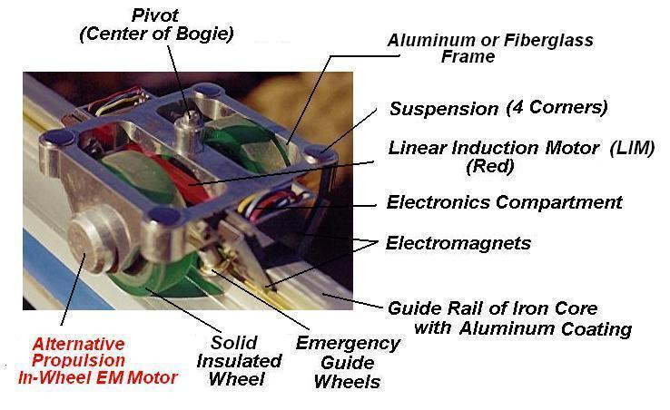
Figure 5 SemiMaglev Urbanaut™ Bogie Components for LIM Propulsion

3.3 Choices of Propulsion Systems - On the Vehicle or In the Guideway [14][18]:
The SemiMaglev Urbanaut is a highly flexible technology in which a typical bogie has been engineered and designed for 3 alternative types of optional propulsion systems dependant on speed, which are illustrated in the following. A magnetic air cushion is typical for all of these, eliminating a large annual operation and maintenance cost of numerous rubber tires for other type of monorails (for example, for a 4-car train, the Hitachi monorail applies 64 rubber tire guide wheels and 32 load wheels that need replacement several times a year).
3.3.1. Alternative I – Propulsion On the Vehicle -- In-wheel Electromagnetic Propulsion Motor for rubber tire traction, for speeds from 0 to 100 km/hr (Fig. 5)
The In-Wheel Electromagnetic Motor Propulsion alternative is a simplified SemiMaglev Urbanaut™ concept adaptable to vehicle speeds up to 100 km/hr when station stops are 1.5 km apart. It implies traction between the rubber tire load-wheels and the runway at all times with a permanent magnetic air-cushion guidance and ability to partially levitate 75% of the vehicle weight to save on cost of energy and maintenance.
The motor provides propulsion with direct traction on the load wheels that have brakes, but no axles and no gears [11][18].
A bogie comes with or without an Electromagnetic Motor for each load wheel depending on vehicle size and power requirements. For example, in a 3-car train the propulsion will be by 4 motors, 2 on each of the bogies within the outer ends of the front and rear cars. (Fig. 9)
3.3.2. Alternative II: Propulsion On the Vehicle -- (ElectroMagnetic System (EMS) Application of Linear Induction Motor (LIM) Propulsion for speeds from 0 to 300 km/hr. (Fig. 6)
The SemiMaglev Technology is unique to the Urbanaut® Monorail only, and is a considerably simpler concept than other wide guideway maglev systems. With station stops as much as 6.5km apart max. speed can be up to 225 km/hr. This alternative utilizes a linear induction motor (LIM) propulsion system, and a pair of electromagnets (EM) that interact with the inclined faces of the guide rail to guide and lift the vehicle. The vehicle can be fully or partial levitated. Tests have shown that keeping 10% of the vehicle weight on the rubber tire load wheels improves smoothness, guidance and stability of the ride, a problem encountered by other maglev concepts.
The Urbanaut® (LIM) propulsion version consists of two primary components:
1) The Primary Coil Stator (Moving component installed in the vehicle) is the LIM, which is basically an ordinary rotary motor that has been opened, rolled out and flattened in shape. The LIM motor is part of the SemiMaglev Urbanaut™ Bogie.
2) The Secondary Conductor (Stationary component) is the guide rail head which is made of magnetic iron, with the top surface of the rail coated with a 5 mm thick aluminum or copper plating, which serves as an electrical conductor. This is a very simple technical and practical arrangement for propulsion and guidance for a maglev vehicle that is locked to a monorail guideway.
The interaction between the two components (the moving and stationary) takes place across a 10 m/m gap. There are no mechanical frictional contacts, no axle, and no gear, which are major advantages of an LIM.
Electric power to the primary stator in the vehicle is provided by an outside source, which can contact insulated power rails, or a non-contact source for high speed vehicles.
The LIM together with an Inverter represents a propulsion system that ensures propulsion, acceleration, deceleration, braking, stopping and operational control of the vehicle. While LIMs used today in rail transportation apply contact steel wheels for guidance, the SemiMaglev Urbanaut™ utilizes a magnetic air cushion, where a constant gap along the inclined faces of the guide rail is maintained by an active controller.
Alternative II - ElectroMagnetic System (EMS)
Maglev Interaction between EM and Magnetic Guide Rail

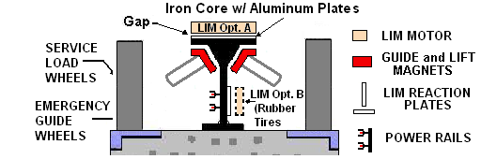

Figure 6A Alternative II
There are several potential locations of the LIM motor unit in the bogie.
a. LIM Interaction with Top of Guide Rail
The LIM unit is attached to the underside of the longitudinal cross brace of the bogie, (Fig. 6A) interacting magnetically with the top portion of the guide rail. In this alternative a Maglev Linear Induction Motor (MLIM) is applied. This MLIM has a repulsive force which will reduce the demand for levitation energy [14].
b. LIM Interaction with Vertical Web of Guideway
This alternative [13] applies air cushion rubber tires which, during partial weighting of the load wheels, may slightly deflect. The LIM is located in the vehicle so it faces the vertical web of the magnetic rail. The surface of the web has a 5 m/m aluminum or copper coating for electrical conductance.
Advantages of LIM

1. Can be custom made to shape and size  2. Traction is not by adhesion  3. Vehicle can climb steeper grades | 4. Needs no wheels, no gear, and no axle.  5. No mechanical links  6. No contact friction
    - Alternative III – Propulsion In The Guideway-- Electrodynamic System (EDS) - Applying Permanent Magnets (PM) in the vehicle, and (LSM) in the guide way for speeds from 10 to 500 km/hr. (Fig. 6B)
Alternative III - Electrodynamic System (EDS)
Providing Levitation, Guidance and Propulsion
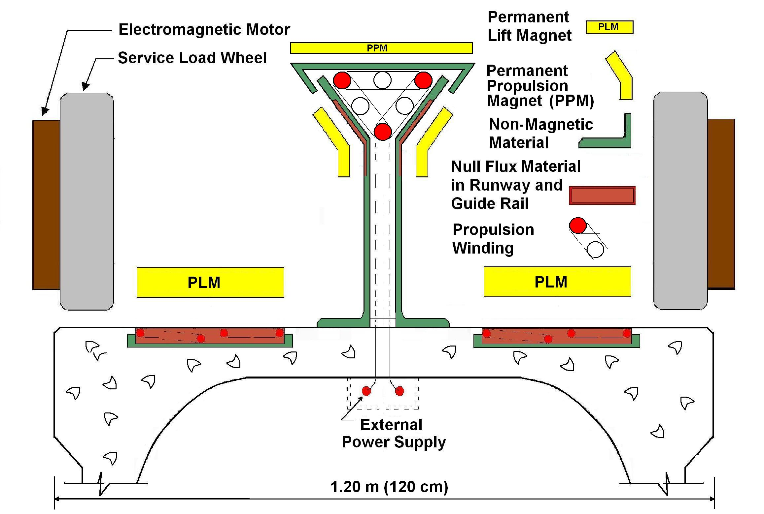
Figure 6B - Alternative III
Permanent magnets (PM), such as the Halbach type, relative small in size, are known to have a larger concentrated magnetic force than regular magnets. They are used as permanent magnets for an Urbanaut® Electro Dynamic (EDS) system. These magnets are arranged in a Halbach Array, where the internal magnetic orientation of each bar is at a right (90°) and (45°) angle to adjacent bars. They also have the advantage that only one face (side) of the bars is magnetic.
In the Urbanaut® EDS vehicles, the PM is mounted to the non-magnetic bogie and is the traveling part of the EDS system. The propulsion PM interacts with the closed packed windings, the stationary part, installed in the head of the guide rail. The propulsion winding commonly is referred to as a Long Stator Linear Synchronous Motor (LSM) since it extends the full length of the guideway.
The interaction between the PM and the null-flux material [22][23] in the runway creates a powerful Repulsive Force (RF) that levitates the Urbanaut® vehicle and maintains an air gap of. 25 mm (1 in.) Such an RF can be maintained without any outside electric power. It represents Passive Magnetic Levitation (PML). Cost of power needed is considerably less than for an Electromagnetic System (EMS), a concept applied to most existing maglev, where no electric power is needed for levitation and guidance
To function with such an EDS as described, a stationary vehicle is dependent on an outside energy source to initiate a starting movement (15 km/hr) of the vehicle, at which time increasing acceleration and speed is activated by maglev interaction between the PM, the LSM, and elements in the guide way. The Urbanaut® utilizes a patented in-wheel small Electromagnetic Motor (EM) to provide such initial movement. [18]
Outside electric power to the EDS and the EM is provided by insulated power rails along the inside of the guideway, which also supplies on-board auxiliary power for control, lighting, air conditioning, etc. The EM motor also serves as an emergency propulsion power when going through stations, switches and in maintenance facilities where the null flux material in the runway is eliminated. This makes the operation much simpler with considerable savings in construction and operation costs. Wide guideway Maglev Systems have not yet demonstrated an operational switch, which will become complex and expensive, since it involves moving (flexing) the entire massive guide way. For example the 22 km (non-maglev) Seattle Rubber Tire Monorail planned will require as many as 30 massive switches, many on top of large elevated platform structures within the city environment, estimated to each cost 10 times more than a simple Urbanaut switch.
Advantages of EDS:
- Low to very high speed capability
- No on-board propulsion equipment needed
- Allows much larger air-gap between magnets and guideway
- Less vehicle weight means savings in rolling stock and cost of energy
- Applies Permanent Repulsive magnets instead of Attractive Electro magnets which need power
3.3.4 Urbanaut® Vehicle Guidance and Stability.
For guidance the Urbanaut® EDS applies Repulsive Permanent magnets in the vehicle bogie facing the guide rail, a similar arrangement and principle as applied for the runway applying repulsive permanent magnets for levitation.
An arrangement of PMs in the bogie interacts with embedded material along the 2 faces of guide rail to create Repulsive Forces, of which one force component provide horizontal guidance and a smaller second component creates a downward counteracting force which has a preloading effect on stabilizing the vehicle for a smooth ride.

4 Vehicle Sizes and Trains
Three different scales (Full, Intermediate, and Small) of the SemiMaglev Urbanaut™ have been designed, engineered and model tested.

4.1 Urbanaut® PRT Vehicle - Small Size
 | The low-profile PRT (Personal Rapid Transit) version features vehicles that can seat 10 passengers or 6 passengers plus a wheel chair. The Low Profile vehicle is unique since the vehicle height from floor to ceiling is less than the average passenger’s height. A central sliding or overhead doorway on each side of the vehicle covers half the cross section of the vehicle [18]. |  | SemiMaglev Urbanaut™ Small Vehicle  6 Seated Passenger + 4 Standees  (or Light Freight)  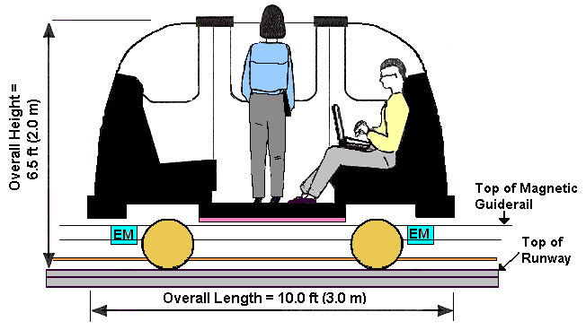  SIDE VIEW
 |  | Figure 7 |  | 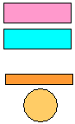 | Linear Induction Motors (LIMs) for Propulsion  2 Pairs of Electromagnets for Maglev (Magnetic Levitation) and Guidance of Vehicle  Fiberoptic Cable for Operation, and Control  Load Wheels applied only during stopping, switching and service
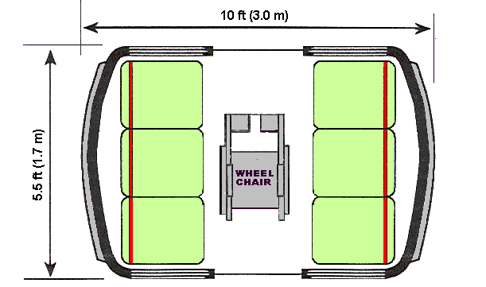
FLOOR PLAN

4.2 Single Vehicle – Intermediate Size
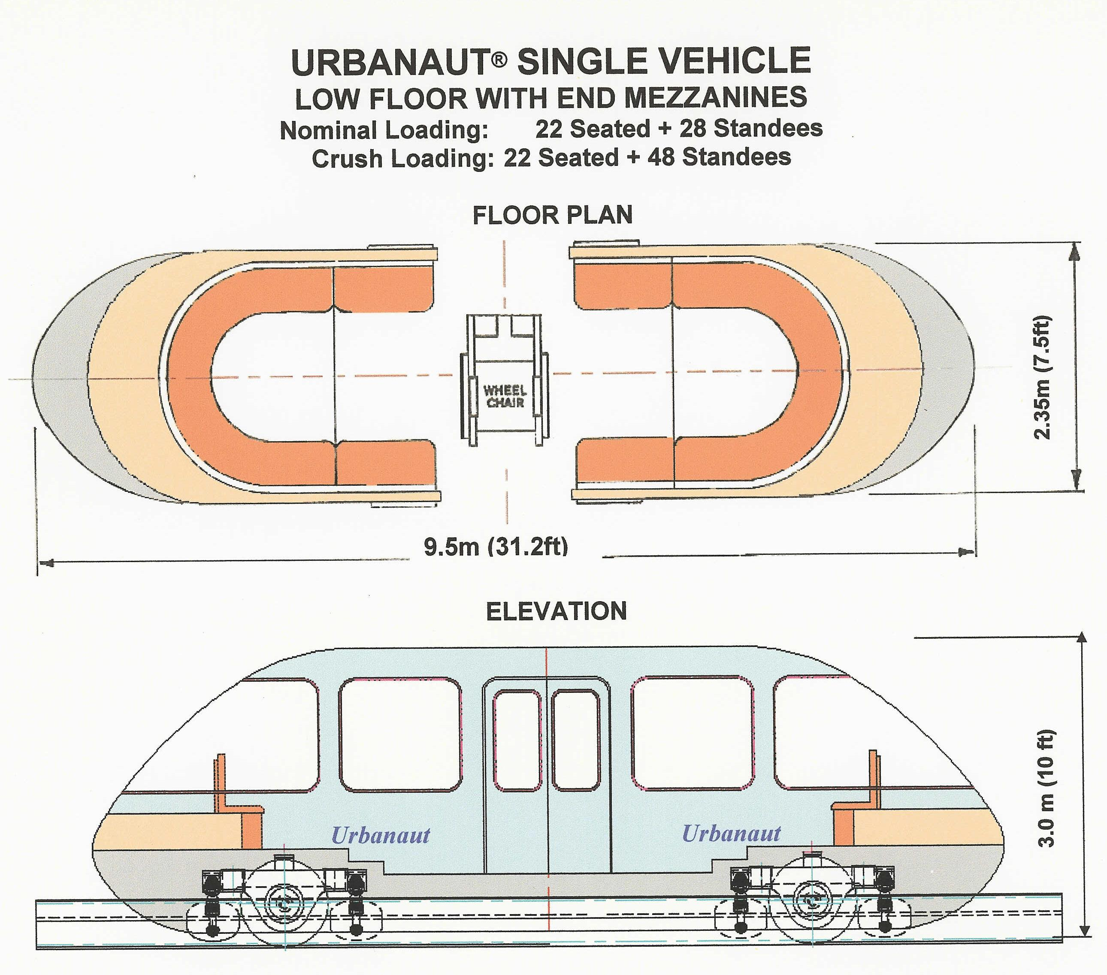 Figure 8

4.3 3-Car Train at Surface – Intermediate to High Speed

SemiMaglev Urbanaut™ 3-Car Bullet Nose Train – Intermediate Size
Max. Nominal Loading: 62 Seated + 72 Standees
Max. Crush Loading: 62 Seated + 102 Standees
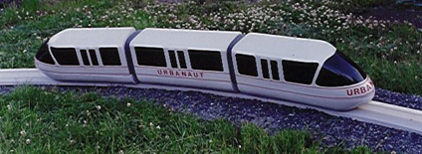
Figure 9 3-Car Train = 80 ft (24.3m) on Urbanaut® Test Guideway at Surface

4.4 6-Car High Capacity Trains on Dual Elevated Guideway

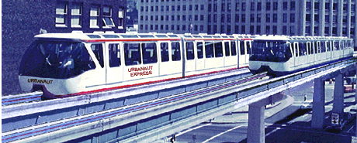

Figure 10

The SemiMaglev Urbanaut™ "Full Scale" System is applicable to trunk lines and as commuter vehicles and for potential large volumes of passenger traffic per hour. It can be made for high speed and slightly longer distances between stops [21].

Full scale Urbanaut® trains of 6 cars with a length of 55 meters (180 ft) has the potential carrying capacity of 40,000 passengers per hour (seated + standees).

5 Guideways and Stations
5.1 Prefabricated Portable Guideway Components
At surface and subsurface only a 1.2 meter wide concrete runway slab is required compared to 2.5 to 3.0 meters for normal non-stabilized maglev vehicles. The elevated guideway of 10,000 psi high strength concrete is a standardized prefabricated system of basically 2 components, a column-to-beam unit and a drop-in center beam [20].
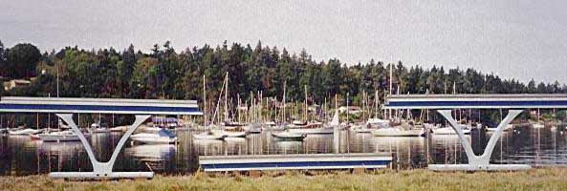
Several types of elevated, lightweight, pre-manufactured guideways have been engineered by Urbanaut® which can be located off-street, having no interference with existing auto traffic. One type consists of two elements; a curved Y-shaped column-to-beam and a center drop-in beam. These two elements allow for free spans of 45 meters between foundations which can bridge a large, busy street intersection. This system allows for flexibility in a network route design in that it can be easily expanded, removed or relocated if need be.
Figure 11
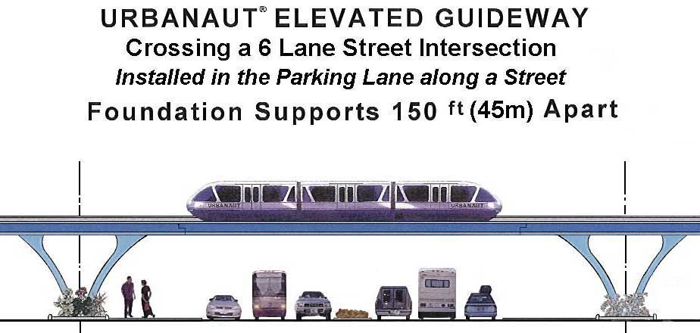
The attractive elevated curved Y-shaped column-to-beam triangular units have a unique structural advantage which makes the elements more slender and lighter, Longer beam spans will reduce the number of foundations needed and interference with underground utilities and will have less environmental impact on the community., leading to considerable lower construction cost
Figure 12
An alternative is an inexpensive guideway assembled with portable lightweight components utilizing vertical hollow columns and a beam way of composite materials with a concrete running slab on top. If needed, heating cables are installed in the runway for regions with cold climates to prevent surface icing.

5.2 Switching of Guideways
Urbanaut® has 3 different electromagnetic simple switches, depending on application: 1. An on-board switch at slow speed; 2. A swivel switch for 2 guideways crossing each other; and
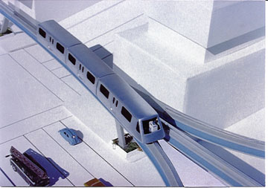
3. A flexible high speed switch.
The central magnetic rail can also be made into a lightweight high speed switch [18], which is flexed by automatic operation to route the vehicle from one guide way to another. This allows the Urbanaut to be used in a network configuration so that larger areas in a community can be served and the vehicles can be utilized more efficiently. It is possible to switch vehicles from a smaller guideway onto a larger one. This has application where smaller, independent single guideway Urbanaut® "circulators", extending from a trunk line into a high density community, will interact continuously with passenger movement to and from, avoiding large, expensive parking lots at the stations.[15] Figure 13

5.3 Stations Adapted to Planned Route Layouts
Monorail stations are a significant part of monorail systems. Efficient stations serve to enhance passenger entry and exit of the monorail vehicles and trains. For a dual guideway, the station is designed and engineered for maximum capacity for 2 trains simultaneously loading/unloading plus emergency unloading in case escalators and stairs fail to expedite passenger exiting to the surface below. Urbanaut® has several versions of stations depending on application and service of passengers and vehicles [16]. Where practical and economically feasible, an Urbanaut® station can be built into a multistory building
Figure 14  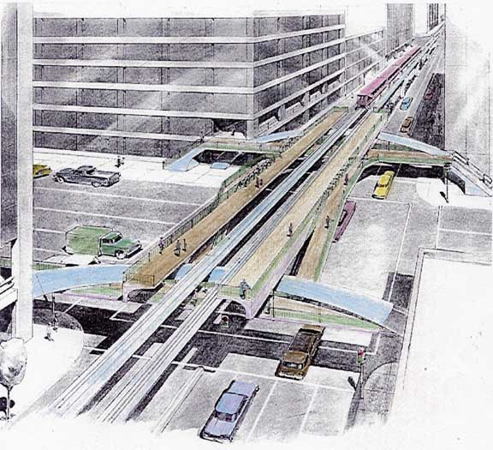 | 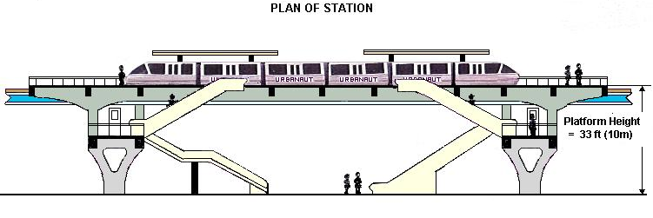  Figure 15  Figures 14 and 15. High Capacity Elevated Urbanaut® Intersection Stations are special stations designed and engineered for unobstructed free flowing surface traffic in both directions below. Such a station has the flexibility for passengers to enter and exit any of the 4 street corners.
An Off-Line Urbanaut® Station shown has dual uses. A) It can load and unload passengers on an Off-Line guideway platform while vehicles are moving by on the On-Line guideway. B) By means of simple Urbanaut® switching provided by the uniquely shaped rail several parallel off-line guideways can be added to a station for by-pass of vehicles, and for storage and servicing of vehicles [18].  Figure 16 | 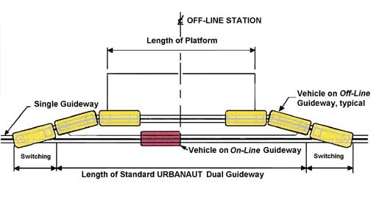

5.4 Passenger Safety and Evacuation

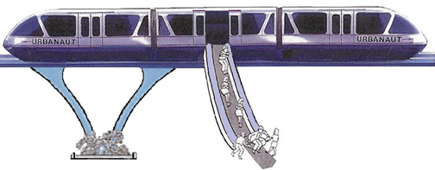
Figure 17
The Urbanaut systems will be fully automated (no drivers) with central control from facilities adjacent to the guideways. Security personnel, by means of audio-visual communication, would view the vehicles inside at all times, during unloading and loading as well as while traveling on the guide way. Laser beams on-board the vehicle will control any irregularities or emergencies on the guide way and bring the vehicle to a stop if needed. Special vehicle escape devices are provided in case of emergency evacuation from elevated guideways.[ ]
6 Project Sample and Costs of SemiMaglev Urbanaut™ (U.S.A.)
The SemiMaglev Urbanaut™’s central rail which enables simple and fast switching allows for the versatility of using a single, smaller, environmentally friendly guideway to feed a larger high capacity trunk line, thus creating a versatile transportation network serving larger areas of the community. The SemiMaglev Urbanaut™’ is the only monorail system that allows this exchange. Such an example is the 160 km (100 miles) long Puget Sound Regional Master Plan (PSRMM) [15], a large scale monorail layout that has the potential to move up to 500,000 passengers daily in Washington State, USA.
An Urbanaut® elevated, surface or subsurface single or dual line right-of-way loop "Circulator" (See Figure 19) can be applied to the distribution of people within urban communities, industry, shopping centers, ports, parks, university and school campuses, sports activities and recreational areas. Such a guide way concept is expandable and can be connected to other loops or guide ways in the future if needed. Several "circulator" loops can be integrated, with transfer from one to another possible.
During high capacity demand periods, vehicles (trains) will be operated continuously around the loop, programmed for maximum service. When there are few passengers, such as at night, the excess vehicles can be docked and/or serviced away from the guideway in an off-line station area.

SemiMaglev Urbanaut™ Circulator
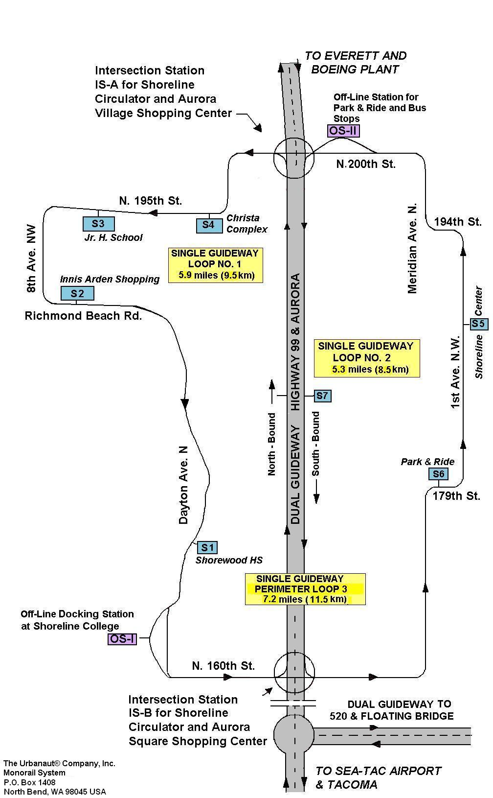
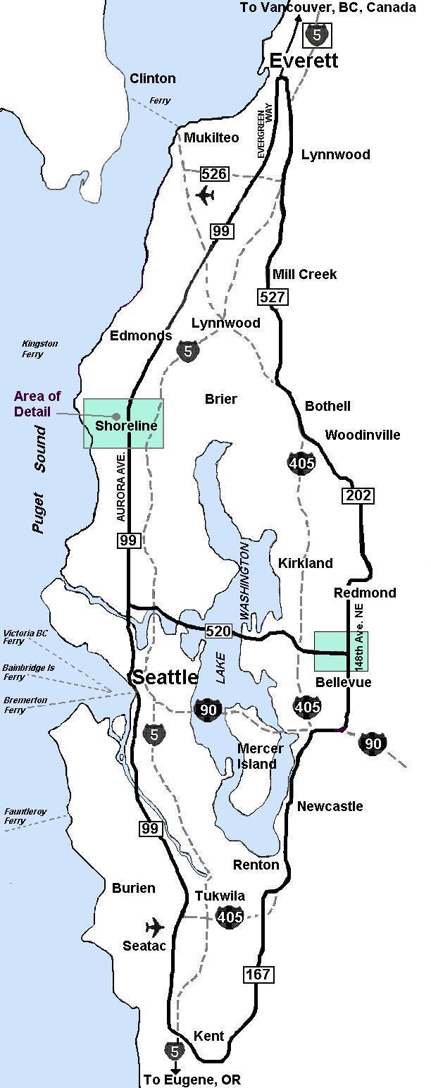
Figure 18 Figure 19 Area of Detail
6.1 Cost of High Capacity Master Plan [21]

Puget Sound Regional SemiMaglev Urbanaut™
Monorail Master Plan
Location: Washington State, U.S.A

TECHNICAL DATA
- 100 miles (160KM) of Elevated and Surface Urbanaut® Dual Guideway
- 50 high capacity stations, 2500 passenger design loading, spaced 2 miles apart
- Trains each capable of carrying up to 1000 passengers
- Daily potential moving capacity: 500,000 passengers
- Maximum speed of trains = 128 km/hr (80 mph) for train stops every station
- Maximum potential speed = 185 km/hr (115 mph) for train stops every second station
- 2 Maintenance facilities
- Apply SemiMaglev Urbanaut™ monorail technology
COST ESTIMATE OF 3 STAGES OF CONSTRUCTION
Stage I | West Side: | Everett to Seatac  With 20 stations | = 64 km  (40 miles) | US$2.6 billion
Stage II | East Side: | Seatac – Kent – Everett  With 25 stations | = 80 km  (50 miles) | US$3.0 billion
Stage III | Central Connector: | Highway 99 across 520 Bridge  With 5 stations | = 16 km  (10 miles) | US$0.6 billion
 | Total | 100 miles of  Urbanaut® dual guideway  With 50 stations |  | US$6.2billion

Cost Estimate does not include:
- Updating the 520 Floating Bridge
- Any underground (tunneling)
- Major utility relocation
- Cost of surface and aerial right of way (to be donated by state and local government)
- Financing of capital
(Revenue and other income may pay for operation, part or all of installation over a 20 year period) (Example: existing Seattle Monorail)
Note: The above cost estimate is for a heavily congested area in the United States of American and would be considerably less in Asia.
6.2 SemiMaglev Urbanaut™ in Median of Freeway
Figure 20
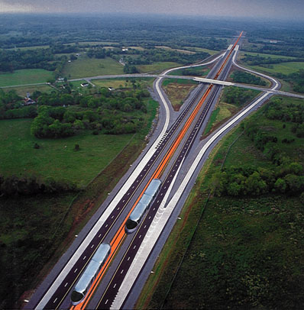
An inexpensive high speed SemiMaglev Urbanaut™ constructed on two parallel 1.2 meter wide slabs in the median of a freeway can favorably compete with autos, thus reducing the congestion and gridlock on the freeway, and provide a relaxed, stress less ride and a much shorter traveling time at reasonable cost [21][29].
There are numerous such application sites along freeways in the USA and abroad. Such an inexpensive high speed SemiMaglev Urbanaut™ as a back-bone system can have passenger transfers to slower speed SemiMaglev Urbanaut™ Circulators or distribution networks serving high density communities and cities. As part of a comprehensive regional transportation plan, applying the same technology throughout has numerous practical and economical advantages. It becomes more efficient, has greater capacity and is a less costly alternative than complicated tunnel diversions and expensive, massive, outdated steel wheel-steel rail concepts.
It should be noted that the speed of 225 km/hr (140 mph) is the upper limit on our freeways in the U.S. because of the limited right-of-way curvatures. Ultra higher speed maglev systems also require very large radial curves, which would require additional right-of-way along freeways, substantially increasing costs.

6.3 Speed/Time Curve for High Speed SemiMaglev Urbanaut™
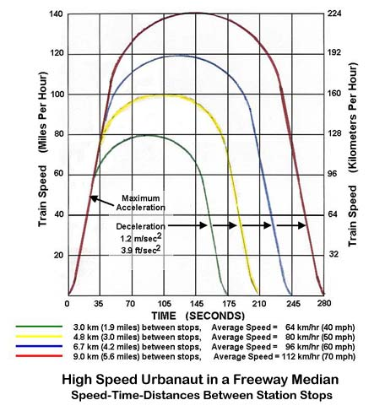
For a SemiMaglev Urbanaut™, a potential speed of, for example, 225 km/hr (140 mph) can be reached at relatively low operational cost. However, because of longer acceleration and deceleration distances, the spacing between stops will have to be considerably longer (Figure 21). Such an Urbanaut® could be suitable for application between cities, high density centers and airports. The high speed, inexpensive SemiMaglev Urbanaut™ could, for example, travel from Vancouver BC, Canada to Eugene, Oregon, USA, a distance of 690 km in approximately 4 hours with stops in 10 cities. This is half the time an auto would take driving nonstop with no freeway congestion. In rush hour traffic the auto may use 12 to 14 strenuous hours.
Figure 21

7. Distribution of Cost for the SemiMaglev Urbanaut™
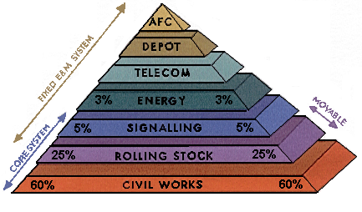  In the SemiMaglev Urbanaut™, the Core System, representing 85% of costs, embraces  1. The Civil Works (Elevated Guideway)  - The Rolling Stock  - Signaling (Automatic control)  The Fixed E&M (Electrical & Mechanical) integrates with the Civil Works [7] | Description of Element  - Civil Works: Guideway, Stations, Switches, Maintenance Buildings  - Rolling Stock: Trains and special vehicles  - Signaling: Train Control System (TCS) and other controls  - Energy: Energy supply  - Telecom: Communication  - Depot equipment and control center  - AFC: Automated fare collection system
Figure 22
Cost of a semi maglev Urbanaut monorail project is quite involved and varies with the passenger capacity of the system, the location, the geography and the route layout of the l guideway, along with the station location and sizes, service and maintenance facilities, switching and total environmental impact on the community. Urbanaut® has the flexibility to integrate future expansion or deletion, which could reduce planning and construction cost.
The graphical cost illustration shown in Figure 22 is specific to the Urbanaut® technology. A SemiMaglev™ Urbanaut® transportation systems consists of many subsystems of which the fixed portion, involving the guideway, stations, switches, maintenance facilities, etc. constitute the main cost.
While the "Cost of Depot" is a relatively small item for the Urbanaut®, it is very large for the straddle-beam type monorails and wide guideway maglev concepts, which require a very large land area with complicated equipment to move the inseparable massive beam ways with the trains on top.
The height of the Urbanaut® is 40% to 60% less than the straddle-beam type monorails built in the USA and Japan because the Urbanaut® technology is not dependent on a beam way like most other monorails. This means the much lighter vehicle and guideway can be constructed for considerably less cost.
A cost comparison by an independent consultant suggests costs may be only 50% of the Alweg type technology (Bombardier and Hitatchi) because of Urbanaut®'s many features discussed above [16]. A Semi maglev
Urbanaut® has the potential capacity of 16 auto freeway lanes at a fraction of the cost, and a comparable impact on the environment of only 10%.

8 Summary - Economical and Practical Advantages of a SemiMaglev Urbanaut™ Compared with Other Transit

The SemiMaglev Urbanaut™ monorail technology is substantially different from conventional straddle-beam type monorails [1] and steel wheel –light rail systems [8] and proposes to solve many of the problems encountered by them. It has been designed so that it does not have to straddle the beam way, but rides on top of a runway and is guided by a central magnetic rail. It has much more flexibility, is much smaller and lighter in weight and considerably less costly to install and operate.
8.1 Comparison of Relative Energy Demand
The energy cost to propel a vehicle is directly related to the weight and size of the vehicle. A heavier, more massive, vehicle will require more energy. A Comparison of Energy Demand shows the SemiMaglev Urbanaut™ will use only 60% of the energy per passenger as the straddle type rubber tire monorails.
Force = mass (acceleration) or (F=ma)
A more massive vehicle will require more energy.
A straddle-beam type monorail with a large number of contact tires has considerable more mechanical friction. Such a monorail vehicle also has a larger cross section and less aerodynamic shape
than the smaller aerodynamic bullet-nose-shaped SemiMaglev Urbanaut™ .
 | New York  Transit | Alweg / Hitachi/  Bombardier | SemiMaglev Urbanaut™
Aerodynamic Drag | 1.3 | 1.0 | 0.60
Mechanical Friction | 1.5 | 1.0 | 0.65
Ac-De-celeration | 1.4 | 1.0 | 0.60
8.2 Operation and Maintenance (O & M)
The installation and operation of an Urbanaut® maintenance facility may cost only one-tenth of a straddle beam type monorail which needs a very large area and dozens of complicated mechanical switches for arranging and moving vehicles on the bulky beamways. The Urbanaut® center guide rail is removed within the maintenance area and the vehicles can be stored parallel to each other either by manpower or by using a custom small pallet lift for a three-car or longer train.
8.3 Advantages in Switching
The concept of the small central rail allows for far more flexible and efficient methods of switching and is more versatile for urban network applications as opposed to the current monorails' back and forth (shuttle) or continuous loop applications which have no practical nor economical switching capabilities.
8.4 Advantages of Steeper Climbing Capabilities
The SemiMaglev Urbanaut™ is environmentally friendly and adjusts to the landscape. The SemiMaglev Urbanaut™ powered by a non-contact LIM can climb considerably steeper grades than light rail, where adhesion between steel wheels and rails is limited to grades of 3 to 4%. Light rail therefore frequently has to construct deep cuts and tunnels, while the SemiMaglev Urbanaut™ can adapt to steeper grades up to 12%, adjusting more closely to the landscape, avoiding expensive tunnels and deep, damaging expensive cuts for rights-of-way through existing residential communities.
8.5 Advantages in Sharp Turn Radius and Steep Climbs
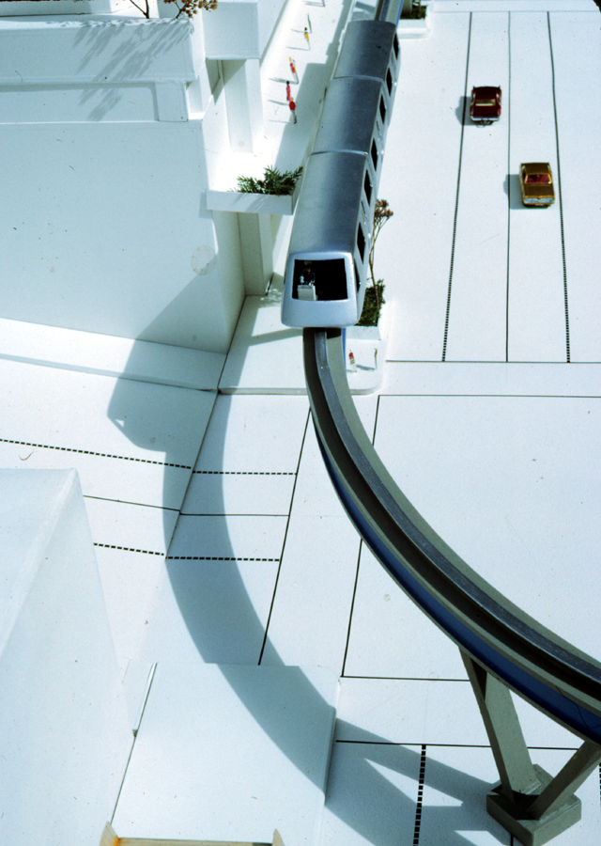
The SemiMaglev Urbanaut™ has a small turning radius of 38 m (125 feet) allowing for sharp curves at 90° street intersections (Figure 23).
Both the large turning radius required and the inability to climb steep hills are major problems for the straddle-beam type monorails and steel light rail in many cities and urban areas.
Shown is a vehicle at a station built into a multistory building.
Figure 23
8.6 Noise Impact
The SemiMaglev Urbanaut™ is virtually noiseless with its aerodynamic shape and no surface friction. The old conventional steel-wheel/steel-rail (light rail) concept is very noisy, and has much greater visual and street disruption impacts, has less flexibility and costs are 3 times greater than the Urbanaut®.

8.7 Advantages in Size
Typical Conventional Steel Wheel Light Rail in Center of Street on Bulky Supports [8]  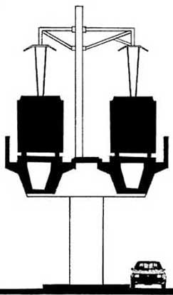  This concept has a large environmental impact on a community |  | SemiMaglev Urbanaut™ Monorail in  Parking Lane [18]  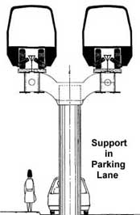  The Urbanaut® has 1/3 the environmental impact of light rail
Figure 24
  - Energy and Cost Advantages
Figure 25
LIGHT  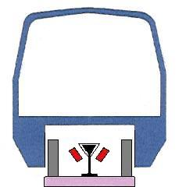  3.0 m (10 ft)  The SemiMaglev Urbanaut®  Energy Saving System  Applies inclined electromagnets to create 90% to 100% maglev (lifting) when the vehicle is in motion. When stationary, the weight is all on the load wheels. The "BEAM" is NOT part of the system, which has numerous advantages | Advantages  - Only a slab is needed at surface and tunnels  - Easy switching of guideways with crossing of 2 guide ways at same level  - A 3-car train has 12 load wheels  - Automatic operation and control  - Height of vehicle is 60% less  - 50% less tunnel excavation  - A lighter vehicle means saving in costs: Construction, Vehicle, Operation  - Greater flexibility in planning and design of guide ways
HEAVY  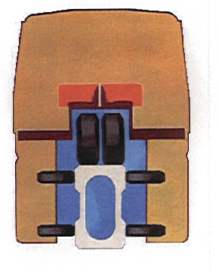  5.0 m (16.5 ft) | Straddled Type Train  In this type of Monorail (which is  antiquated 50-year old technology)  the massive "BEAM" is part of the Basic System.  A 3-car Train has 60 tires that need  frequent replacement.  Examples are:  Disneyland and Disney World  Seattle Monorail  Las Vegas Monorail  Japanese Monorails

9 References
- "Alweg Monorail", Alweg Rapid Transit Systems of Washington State, Inc., USA Wegematic Corp, 1962.
- "Assessment of CHSST Maglev for U.S. Urban Transportation", FTA Report No. FTA-MD-26-7029-2002.1, July 2002.
- Chinese Patent #ZL99815123.8, Monorail System, Einar Svensson, Granted 10/8/03.
- Chubu HSST Development Corp.," HSST", Japan.
- Einar Svensson, "Enskinnebaner – utvikling og anvendelse…", Teknisk Ukeblad, 9.August, 1962, Oslo, Norway.
- Einar Svensson, "The Lightweight Urbanaut People Mover System," Automated People Movers, ASCE Proceedings, 1985.
- GEC Alsthom, Transport Systems: Products; "Electrical and Mechanical System/Core System", 1998.
- Jeff Boone, "Regional Freeway Monorail", Seattle, WA, USA.
- Jeff Brown, "Maglev Technology Comes of Age in Shanghai", Civil Engineering, Febr. 2003, USA.
- John E. Svensson, "SemiMaglev Urbanaut™ Bogies of Metal and Fiberglass", design, engineering and manufacturing applying ProEngineer data (proprietary).
- Magnet Motor Co.; Design, Engineering and Manufacturing Data of an In-Wheel Electromagnetic Motor for the Urbanaut Co., Inc. (proprietary).
- "Magnetic Levitation (Maglev) Technologies", Japan Railway & Transport Review No. 25.
- Michelin; Rubber tire load wheels for the SemiMaglev Urbanaut™; Urbanaut® Monorail Co., Inc (proprietary).
- Power Superconductor Applications Corp, Design and Engineering of MLIM for the SemiMaglev Urbanaut™ Monorail (proprietary).
- "Puget Sound Monorail Master Plan", The Urbanaut® Company, Inc., 2003.
- "Technology Presentation", CD; The Urbanaut® Company, 2003.
- Transportation Research Group, "Seattle Monorail Demonstration Study", U. of Washington, October, 1962.
- U.S. Patents #5,845,581, and #6,450,103, Monorail System – Semi-Maglev, Einar Svensson, Granted 12/8/98 and 9/17/02.
- U.S. Patent #6,564,515, Support Structure, Einar Svensson, Granted 5/20/03.
- U.S. Patent #6,571,717, Y-Shaped Support Structure, Einar Svensson, Granted 6/3/03.
- Urbanaut® web site: http://faculty.washington.edu/~jbs/itrans/urbanaut.htm or search for "urbanaut monorail".
- He, J.L., Mulcahey, T.M, et.al., "Computer Modeling and Experimental Verification of Figure-Eight-Shaped Null-Flux Coil Suspension System", Center for Transportation Research, Energy Systems Division, Argonne Nat'l Lab., Dec. 1994.
- John E. Svensson, "Experimental Testing of Static and Dynamic Drag of Null Flux Type Material Embedded in the Urbanaut® Guideway" (Proprietary).
- Einar Svensson, "Ground Effect – Significant Design Criteria for Minimization of Vehicle/Guideway Dynamics Interaction" (Proprietary).
- Chinese Patent "ZL99815123.8; Monorail System – SemiMaglev", Einar Svensson, Granted 10/8/03.
- Einar Svensson, Power Point Presentation: "Design, Engineering and 'Construction of the Alweg Monorail for the Seattle World's Fair 1962."
- John Svensson, John Mucha and Einar Svensson, "Design, Engineering and Construction of 1:10 Scale Elevated SemiMaglev™ Urbanaut®"
- High Speed SemiMaglev™ Urbanaut® in Median of Interstate I5 and I90 Freeways, Washington State, USA

